CONWY AREA 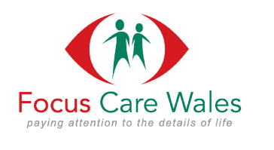

SUPPORT WORKER VACANCIES (Male & Female)

Job Role
You will be supporting people who have a learning and/or a physical disability with their day-to-day lives; enabling them to maintain their independence through ACTIVE SUPPORT with each individual. The role may include elements of personal care.

A typical day can include support at home, work or accompanying our service users with general activities such as their weekly shop or any chosen leisure activities including swimming / trips to the cinema, theme parks, community activities, safari parks or zoos.

If you are kind, compassionate, patient and friendly then you will make the perfect support worker - no experience is required and full training is given.

Hours: 16 – 37.5 per week
Pay: £13.45 p/hr
Work patterns: Full Day shifts/ Weekends / Evenings / Sleep ins
Type of Support: Supported Living & Community Support

Requirements
- An Understanding of working in Health & Social Care
- Flexible Approach to Work
- Working alternate weekends
- Good communication skills
- Good level of written English

Benefits
- 32 days annual leave increasing to 35 days with continued service (including statutory entitlement/ pro rata for part time staff)
- Bravo Benefits Scheme (Retailer discount scheme)
- TELUS Employee Assistance Programme (for staff and family members)
- Blue Light Card Discount eligibility
- NEST pension Scheme
- Cycle to Work Scheme
Rewards Schemes for:
- Employee Referral – Accumulative pay award (up to £150)
- Long Service - Accumulative pay award (from £100 - 500)
- Employee of the Month (£50 Gift Card)
- New Ideas Scheme (£25 Gift Card)
- CEO Commendation (for going above & beyond)

